Warning
- Battery installation method.
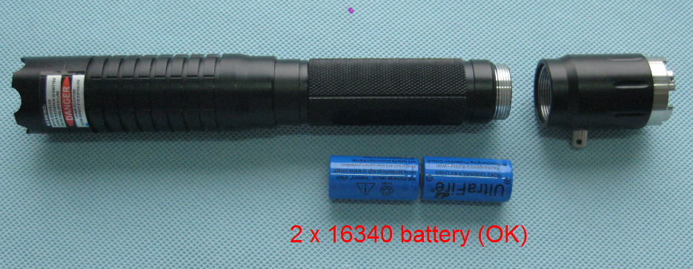
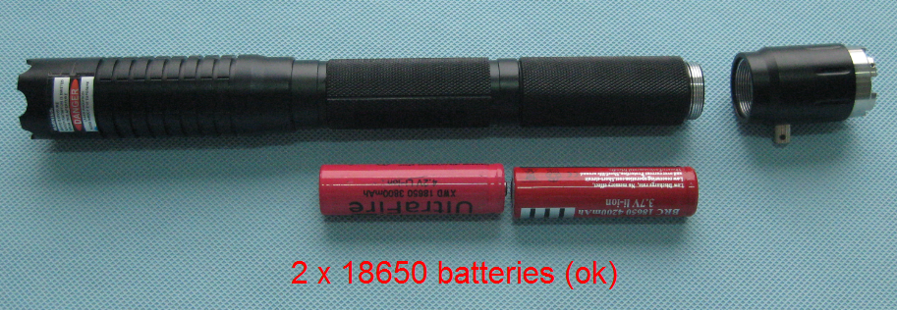

Never install 3 batteries; it will burn out the laser as quick as a flash.
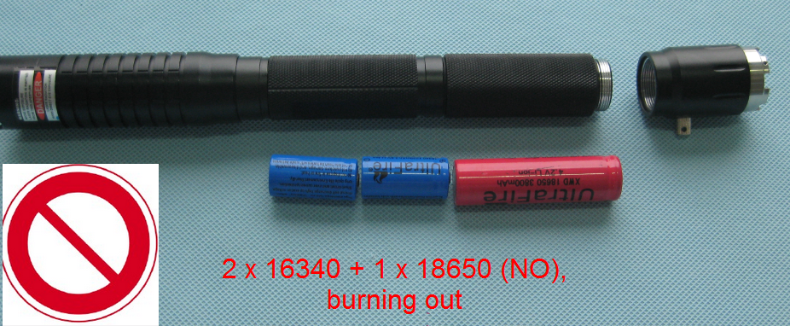

If you brought this blue laser pointer from our web store, please according to the following standards, strictly regulate the use of:
The International Electrotechnical Commission (IEC): the establishment and management of international laser safety standards, IEC 60825-2007
American: America National Standards Association (ANSI) laser safety committee Z136-2000 standard
China:
A) Radiation safety of laser products: GB7247.1-2001
B) Safety standards of laser protection device: GB18151-2000
C) Laser safety standards: GB18217-2000
D) Safety standards of laser operation field: GB10435-1989
According to the classification of laser products (GB 7247.1-2001) standard, this product belongs to the class IV: even by the laser diffuse reflection also is likely to cause harm, will burn the skin, ignite flammable materials, you should be particularly careful when the user operates this kind of laser source.
The wavelength of this product is the 445NM, visible light (400nm-700nm) laser, and the impact on the eye mainly for the photochemical and thermal effects induced retinal injury, The main effects on the skin mainly as dark , light-sensitive effect, skin burns .
Continuous density laser irradiation eyes will cause irreversible damage, please exercise caution when in close use, and please wear protective goggles for protection.
When not in use, should be placed in the minors cannot get place, and remove the batteries, turn off the switch, twist out safety pin for safekeeping, to prevent accidental injury events.
Our purchasers to determine before buying, we have notification obligation, the buyer must be observed, if the buyer does not listen to advice all the consequences of what happened, borne by the buyer, the shop is not responsible.
In addition, the restaurant lasers prohibit the sale to minors, please note!

Blue 3W laser pointer Precautions
(Important, be sure to read)

The blue 3W upgrade project description:
- After the upgrade, the attack of head is the 316 stainless steel material, high hardness, sufficient for self-defence and emergency hit hard materials like glass or material under normal circumstances.

- The laser module heat radiating area increased one-third compared with the blue 2W, the better ability of continuous working.

- Added safety latch and switch contacts, safety pin made from the plastic material to copper nickel-plated contacts plus higher conductive properties of 24K gold.

- Added the ignition position line, to help with quick guide to had not been exposed to laser products buyers.

Have to take practical action to optimize the product, so that customers buy products with more practical value in use and continuous improvement, we will continue to move forward, and strive to bring you better products, never negative the laser lover’s love.

The blue 3W instructions:
1: using a laser lamp, without prolonged tube with two short battery, positive towards the tail cover, short battery and long battery cannot mix, also cannot be loaded at the same time 4 short batteries, battery single voltage is 3.7V, the flashlight for 7.4V driver.
Add the extension tube to put two long battery, positive towards the tail cover, cannot hold two small batteries a large battery.
Note: If fault wrong battery lead, is not in the scope of free warranty.

2: the laser diode is a high fever components, overheating could cause the laser diode accelerated aging, affect the service life of the laser pointer, so we suggest that when the heating is better in your hand, close it and cooling it.

3: multi gear products with exclusive four grade, dimming mode, divided into strong, weak and slow, flash mode, all the stalls are with slow start protection, light way: open the flashlight quickly after pressing the switch two times, into the next gear, laser flashlight with memory model, closed hand electric five seconds later, open default reply to open before the stall next time.

4: the use of LED lighting lamp holder, an 18650 battery driver, LED lamp is negative, so the battery negative pole with laser instead, with the correct method is positive in spring, negative towards the tail cover.
LED flashlight, with strong, weak, in the flash, SOS five stalls, continuous press two can enter the next gear.

5: Prohibited dismantle laser pointer, otherwise there may void the warranty.

6: the prohibition by the human body, especially the eyes, any accidents such as buyers do not follow the instructions as a result, the shop will not bear any responsibility.

